GP Spark Implementation Manual
Luisuan Technology GP Series- Peregrine Spark
Document No. | LSJS.EBOF2026A-2.A.0
Stage | C
Version | A.0

Prepared by:
Reviewed by:
Verified by:
Co-signed by:
Standards-reviewed by:
Approved by:
Guangdong Luisuan Technology Co., Ltd.

File Update History
Date | Updated By | Version | Preparation / Modification Content
2026-02-10 | Li Hang | A.0 | Initial version established
2026-0613 | Jacky Kuan/EH | AE.0 | Initial version established to EN version

1 Abstract
This document primarily describes the implementation process and precautions for the Luisuan Technology ForinnBase GroundPool - Series Peregrine GP Spark. For more detailed product information, please refer to the User Manual and User White Paper.

1.1 Product Introduction
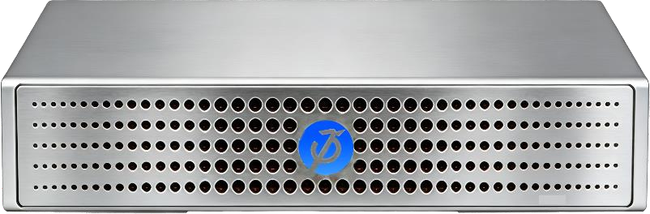

Luisuan Technology's GP Spark is a data-center-grade NVMe-oF storage node. Through its hardware offload engine, the RDMA (RoCEv2) and NVMe-oF protocol stack are fully implemented end-to-end within a dedicated chip, achieving end-to-end data acceleration. A single 100GbE port delivers up to 2.7 M IOPS, 20µs end-to-end latency, and 10GB/s throughput. Within a compact 150mm × 150mm × 26mm(0.58L) chassis, the unit supports four M.2 SSD bays while consuming only 100W. Its unibody aluminum-magnesium alloy enclosure serves as an efficient heat-spreading body, and its silent fan maintains a quiet office environment even under 100% load. GP Spark condenses the performance, capacity, and data services of traditional enterprise-grade high-performance storage capable of delivering NVMe-oF performance into a desktop-sized footprint, providing a plug-and-play storage acceleration solution that can be placed directly on a desk for data-intensive workloads such as AI training, real-time visual effects, and quantitative finance.

2 System Requirements for Product Integration
The following are the EBOF-compatible operating system versions and recommended configurations:
- CentOS 7.5 or later.
- Ubuntu 18.04 or later.
- Domestic operating system Kylin V10 SP1 or later.
- UnionTech UOS, CS2C , and Loongson operating systems.
- Rocky Linux release 9 or later.
- For other unsupported systems, please upgrade the Linux kernel to Linux kernel 4.13.0 or later.

2.1 RDMA Network Cards(NICs)
Luisuan Technology uses Mellanox network cards from NVIDIA, as well as its own self-developed network cards, to connect GP products.
- NVIDIA Mellanox ConnectX Series
- Luisuan Technology LS00201V11 Series

2.2 High-Speed Cables
Luisuan Technology GP Series products require 100GbE or higher DAC (Direct Attach Copper) or AOC (Active Optical Cable) cables for connections between servers or switches. For extended distance requirements, fiber optic cables may be used to achieve the desired performance.

3 GP Spark Connection and Mounting Process

3.1 Network Configuration
After completing the network configuration(assigning an IP address to the port, as shown in the figure below.), attempt to ping the storage port (default IP is 10.10.10.100/24).
ping 10.10.10.100
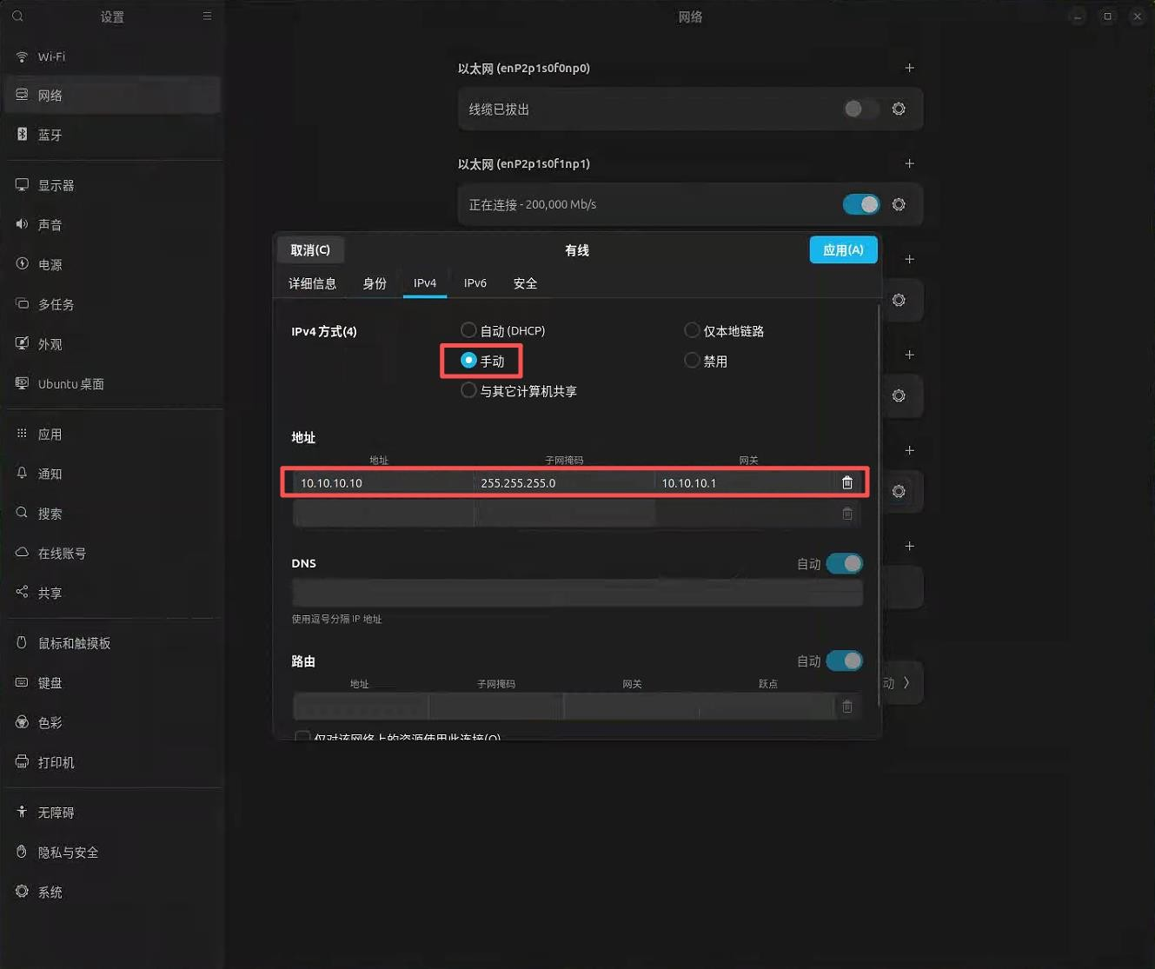

[Figure 3.1: Desktop network settings — manual IPv4 configuration of the network port]

3.2 Network Issue Troubleshooting
If the GP Spark port can be pinged normally, the following content may be skipped.
If the port cannot be pinged, verify the following items :
- The cable is properly seated, with no looseness.
- The port status is UP.
- The IP address configured on the host for the GP Spark connection falls within the 10.10.10.0/24 subnet.

3.3 Modifying NIC Auto-Negotiation
Note: If all of the above conditions are met but the NIC port still cannot reach the UP state, follow these steps:
Use the following commands to disable the NIC's auto-negotiation and manually set it to 100G mode. Replace enP2p1s0f0np0 with the actual NIC interface name on your system, then check whether the port status becomes UP.
Disable auto-negotiation and manually set the speed to 100Gbps:
ethtool -s enP2p1s0f0np0 speed 100000 duplex full autoneg off
Re-enable auto-negotiation:
ethtool -s enP2p1s0f0np0 autoneg on

3.4 Installing NVMe Software
The host system integrating with the GP Spark product requires NVMe-related management tools to connect to the EBOF device. After configuring the IP address, install nvme-cli first. The host must have internet access to download the package.
CentOS: yum install -y nvme-cli
Ubuntu: apt-get install nvme-cli
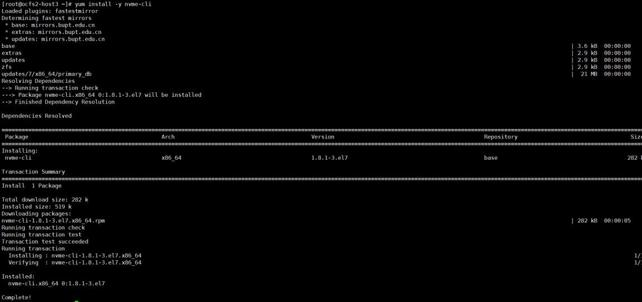

[Figure 3.4: Example terminal output of the nvme-cli installation process]

3.5 Loading RDMA Drivers
Use the following commands to load the RDMA-related kernel modules:
modprobe nvme-fabrics
modprobe rdma_cm
modprobe nvme
modprobe -v nvme-core multipath=0
modprobe -v nvme-rdma register_always=0

3.6 Configuring Jumbo Frames on the NIC
ip link set dev enp33s0f1 mtu 5000

3.7 NVMe SSD Disk Discovery
Use the following command to discover the NVMe SSD targets on the GP Spark:
nvme discover --transport=rdma --traddr=$ip --trsvcid=4420
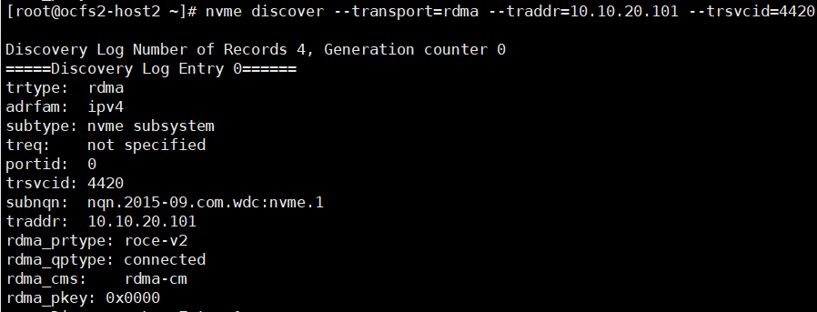

[Figure 3.7: Example Discovery Log output, including fields such as trtype, adrfam, subtype, treq, portid, trsvcid, subnqn, traddr, rdma_prtype, rdma_qptype, rdma_cms, and rdma_pkey]

3.8 Disk Mounting
$IP is the IP address corresponding to the device port, and $nqn corresponds to the subnqn field retrieved from the discovery log. A successful connection command will not return any output; you can verify the status using lsblk or nvme list.
nvme connect --transport=rdma --traddr=$ip --trsvcid=4420 --nqn=$nqn --nr-io-queues=8

4 Important Notes

4.1 Avoid Adding NVMe-oF Disk Mount Entries to /etc/fstab
Because Luisuan EBOF devices expose storage via the NVMe-oF Ethernet protocol rather than a local PCIe bus, the OS cannot recognize these NVMe SSDs during the initial boot sequence when /etc/fstab executes permanent mounts. This will result in a connection error. Adding standard local mount entries to fstab may cause the disk mounting to fail or completely prevent the operating system from booting.
If this misconfiguration has already caused a boot failure, enter Single User Mode, edit the /etc/fstab file, and remove the NVMe-oF disk mount entries. This will allow the system to boot normally, after which the SSDs can be manually connected and mounted using nvme-cli commands.

5 SupremeRAID™ SE Integration
This section describes how to install Graid Technology SupremeRAID™ SE on the host, how to build SupremeRAID™ RAID components (PD / DG / VD) on top of the NVMe SSDs exposed by the GP Spark over NVMe-oF, and how to configure NVIDIA MPS so that the SupremeRAID™ SE controller GPU can be safely co-resident with other CUDA workloads. The procedures below are based on the SupremeRAID™ SE Linux Driver 2.0.0 and the SupremeRAID™ SE User Guide for Linux.
Note — Connection method: SupremeRAID™ SE consumes the GP Spark NVMe-oF namespaces as physical drives. The namespaces must first be connected on the host with nvme-cli (see Section 3.7 and 3.8) so that they appear on the host as local block devices (/dev/nvmeXn1); SupremeRAID™ SE then uses those connected namespaces. This connection is manual and does not persist across reboots. To bring the GP Spark targets up automatically at boot, use the standard NVMe-oF auto-connect mechanism (discovery.conf + nvmf-autoconnect.service) described in Section 5.2.1. GPU environments with NVLink are not supported by SupremeRAID™ SE.

5.1 Installing SupremeRAID™ SE
Prerequisites
- CPU: 2 GHz or faster with at least 8 cores; RAM: 16 GB minimum.
- A supported NVIDIA GPU (Turing, Ampere, Ada Lovelace,Blackwell, Grace Blackwell GB10). Quadro/RTX-class cards offer larger BAR1 memory, enabling direct GPU–NVMe communication and significantly better performance on Linux.
- Internet access on the host so the pre-installer can download required dependencies.
- BIOS: It is recommended to disable IOMMU (AMD) / VT-d (Intel), and to disable UEFI Secure Boot. If Secure Boot must remain enabled, the NVIDIA kernel module must be signed.
Step 1 — Run the Pre-installer. Download the latest SupremeRAID™ SE pre-installer (which includes the NVIDIA driver) from the Graid Technology website, make it executable, and run it. The pre-installer configures all required dependencies and the NVIDIA driver automatically.
sudo wget [pre-installer-link]
sudo chmod +x [pre-installer-filename]
sudo ./[pre-installer-filename]
Step 2 — Run the Installer. Download the installer matching your GPU architecture (SR-SE-TU / -AM / -AD / -BW) from the Driver Package section, make it executable, and run it.
sudo wget [installer-link]
sudo chmod +x [installer-filename]
sudo ./[installer-filename]
Step 3 — Accept the license. At the Welcome page select Next, review the end-user license agreement, accept it, and click Next to complete the installation.
Step 4 — Open the Management Console. The SupremeRAID™ SE Management Console requires TCP port 50060 to be open. If 50060 is already in use, edit /etc/graidmgr/service.conf to set a custom web_port and web_addr, then restart the service.
Step 5 — Enter the host token. Enter the host token into the Management Console. If the token is lost, regenerate it with:
sudo graid-mgr host_token gen
Step 6 — Select a license mode and bind the GPU. Choose Perpetual (requires a V2 license key for the 2.0 driver) or Subscription (monthly billing). For Perpetual, set a password; for Subscription, log in with your portal email and password. Finally, bind your GPU to start the RAID setup.

5.2 Creating PD / DG / VD from GP Spark NVMe-oF Devices
SupremeRAID™ SE organizes storage into four logical components: Physical Drive (PD), Drive Group (DG), Virtual Drive (VD), and Controller (CX). The workflow below assumes the GP Spark NVMe-oF namespaces have already been connected on the host using the nvme connect procedure in Section 3.8, so that they appear as local /dev/nvmeXn1 devices. Confirm they are visible before continuing:
nvme list

5.2.1 Persistent Auto-Connect at Boot
The nvme connect command in Section 3.8 establishes a manual connection that does not survive a reboot. Because the SupremeRAID™ SE physical drives are built on top of these namespaces, the GP Spark targets must be connected before the SupremeRAID™ SE service brings up the RAID components. Use the standard NVMe-oF auto-connect mechanism provided by nvme-cli so the connection is re-established automatically on every boot.
Step 1 — Add the target to the discovery configuration. Append a discovery entry for the GP Spark port to /etc/nvme/discovery.conf. Replace the address with the GP Spark device port IP.
echo "--transport=rdma --traddr=10.10.10.100 --trsvcid=4420" >> /etc/nvme/discovery.conf
Step 2 — Connect all discovered subsystems. Run a one-time connect-all to verify the entry works:
nvme connect-all
Step 3 — Enable the auto-connect service. Enable the systemd service so the targets in discovery.conf are connected automatically during boot.
systemctl enable nvmf-autoconnect.service
Note: The auto-connect service depends on the network being up (it runs after network-online.target). Ensure the RDMA / storage interface is configured to come up at boot and is not torn down by NetworkManager DHCP cycling on the storage link. As stated in Section 4.1, do not place the NVMe-oF namespaces in /etc/fstab; let auto-connect bring up the targets, then mount the SupremeRAID™ SE virtual drive(s).

5.2.2 Auto-Connect Compatibility Across Distributions
The nvmf-autoconnect.service unit is provided by the nvme-cli package, so it is available on any GP Spark-supported distribution that ships a current nvme-cli. Behaviour differs mainly in two areas: whether the unit is installed by default, and whether the storage network is genuinely up when the service runs. The table below summarizes the per-distribution situation.
Distribution (GP Spark supported) | Auto-connect unit | Notes for GP Spark (RDMA / RoCEv2)
RHEL / Rocky / AlmaLinux 8 & 9 | Shipped in nvme-cli | nvmf-autoconnect.service is present and enabled the standard way. Recommended baseline for GP Spark; native NVMe-oF RDMA support is mature on kernel 4.18 / 5.14.
CentOS 7.5 – 7.x | Old nvme-cli | The shipped nvme-cli and 3.10 kernel have limited NVMe-oF RDMA support. Per Section 2, upgrade to kernel 4.13+ . If nvmf-autoconnect.service is absent, create the equivalent unit manually (see Note below).
Ubuntu 18.04 / 20.04 / 22.04 / 24.04 | Shipped in nvme-cli | Unit present. On Ubuntu, network-online.target maps to NetworkManager-wait-online or systemd-networkd-wait-online — confirm the storage interface is covered so the link is up before connect-all runs.
Kylin V10 SP1+ / UOS / CS2C | Shipped in nvme-cli | RHEL/openEuler-derived with systemd; the unit behaves as on RHEL. Verify the nvme-cli build actually installs the unit (rpm -ql nvme-cli).
Loongson (LoongArch) | Distro-dependent | Different CPU arch but same systemd userspace. Confirm nvme-rdma and the RDMA NIC driver are available for the kernel in use before relying on auto-connect.
Two GP Spark-specific cautions apply on every distribution:
- Load the RDMA fabric module. GP Spark uses NVMe-oF over RDMA (RoCEv2). The stock unit only runs modprobe nvme-fabrics (some builds load nvme_tcp), neither of which guarantees nvme-rdma is present. Ensure it loads at boot, for example with a modules-load entry:
echo nvme-rdma > /etc/modules-load.d/nvme-rdma.conf
- Order after the storage link is really up. A common failure is the service running before the RDMA interface is reachable, producing a connect timeout at boot. If this occurs, add a drop-in that delays the service until the storage interface is online (for example via a dependency on the interface’s network-online wait service), rather than relying on the default After=network-online.target.
Note — if the unit is missing (e.g. older CentOS 7): create an equivalent oneshot unit at /etc/systemd/system/nvmf-autoconnect.service with the content below, then reload and enable it. This reproduces the upstream unit on systems whose nvme-cli predates it, with the RDMA module added for GP Spark.
[Unit]
Description=Connect NVMe-oF subsystems automatically during boot
ConditionPathExists=/etc/nvme/discovery.conf
After=network-online.target
Wants=network-online.target
Before=remote-fs-pre.target

[Service]
Type=oneshot
RemainAfterExit=yes
ExecStartPre=/sbin/modprobe nvme-rdma
ExecStart=/usr/sbin/nvme connect-all

[Install]
WantedBy=default.target
systemctl daemon-reload
systemctl enable nvmf-autoconnect.service
Variant — traditional network service (CentOS 7 without NetworkManager): On systems still using the legacy network.service (initscripts) instead of NetworkManager, there is no *-wait-online.service to delay network-online.target, so ordering after it does not guarantee the storage link is up. In that case, order the unit after network.service and add an explicit reachability gate on the GP Spark port (replace the IP with your device port address):
[Unit]
Description=Connect NVMe-oF subsystems automatically during boot
ConditionPathExists=/etc/nvme/discovery.conf
# Legacy initscripts: order after network.service, not the wait-online target
After=network.service
Wants=network.service
Before=remote-fs-pre.target

[Service]
Type=oneshot
RemainAfterExit=yes
ExecStartPre=/sbin/modprobe nvme-rdma
# Gate on the GP Spark port being reachable before connecting
ExecStartPre=/bin/sh -c 'until ping -c1 -W1 10.10.10.100; do sleep 2; done'
ExecStart=/usr/sbin/nvme connect-all

[Install]
WantedBy=multi-user.target
Tip: If NetworkManager is in use, prefer ordering after NetworkManager-wait-online.service and make sure that service is enabled. The ping gate above is still a useful safeguard on RDMA links, because the interface can report up before the RoCEv2 path to the GP Spark is actually usable.
Step 1 — Create Physical Drives (PD). Log in to the SupremeRAID™ SE Management Console and navigate to RAID Management / Physical Drives. Click Create and select the connected GP Spark NVMe namespaces to add as physical drives. SupremeRAID™ SE supports a maximum of 8 physical drives. A healthy PD that has not yet joined a DG shows the state UNCONFIGURED_GOOD.
Step 2 — Create a Drive Group (DG). Navigate to RAID Management / Drive Group and click Create. Select the physical drives and the desired RAID level. SupremeRAID™ SE supports RAID 0, 1, 5, and 10, with these minimum drive counts:
- RAID 0: at least 1 drive (no redundancy)
- RAID 1: at least 2 drives
- RAID 5: at least 3 drives
- RAID 10: at least 2 drives
When the DG is created, the driver initializes the physical drives for the chosen RAID mode. If all drives support the deallocate (DSM) command, Fast Initialization is used and the DG becomes OPTIMAL immediately; otherwise Background Initialization runs, during which the DG remains usable. A maximum of 8 drive groups is supported. Note that only RAID 5 can enable the distributed journaling (double-failure protection) feature, and if you bypass journal-space creation it cannot be recreated later.
Step 3 — Create a Virtual Drive (VD). Navigate to RAID Management / Virtual Drives, click Create, and select the drive group in which to create the VD. The VD is the usable RAID volume. When created, a device node /dev/gdgXnY appears on the OS. You can create up to 1023 virtual drives per drive group. For RAID 0 and RAID 10, configurable strip sizes are 4k, 8k, 16k, 32k, 64k, and 128k.
Step 4 — Make a filesystem and mount. Create a filesystem directly on the VD device node and mount it. To benefit from NVMe DSM deallocate (trim) pass-through, mount with the discard option.
mkfs.xfs /dev/gdg0n1
mount -o discard /dev/gdg0n1 /mnt/graid
Note: As described in Section 4.1, do not add the underlying NVMe-oF mount entries to /etc/fstab. Because the GP Spark namespaces are reached over the network, they are not available at the time fstab runs during early boot. The NVMe-oF targets must be connected (Section 3.8) and the SupremeRAID™ SE service must be running before the RAID components and their virtual drives become available.

5.3 Configuring NVIDIA MPS
NVIDIA Multi-Process Service (MPS) is a runtime that lets multiple CUDA processes share a single GPU concurrently by routing their work through a single shared GPU context, improving utilization and reducing context-switching overhead. SupremeRAID™ SE uses the bound GPU as its RAID controller. If the same physical GPU must also run another CUDA workload (for example an inference engine co-resident on the host), enabling MPS allows the SupremeRAID™ SE controller process and the other CUDA client to coexist on the GPU rather than serializing through default time-slicing.
Step 1 — Choose a pipe and log directory. The MPS control daemon and clients communicate through named pipes. Choose one pipe/log directory and use it consistently for the daemon, every CUDA client, and the SupremeRAID™ services (Step 6). This guide uses /tmp/nvidia-mps. Note that any service started with PrivateTmp=true receives a private /tmp, so a daemon and a client would not see each other’s pipes and the client silently falls back to a private context (no MPS). If any SupremeRAID™ or client unit sets PrivateTmp=true, set PrivateTmp=false on it (see Step 6) so the /tmp pipe directory is shared.
export CUDA_MPS_PIPE_DIRECTORY=/tmp/nvidia-mps
export CUDA_MPS_LOG_DIRECTORY=/tmp/nvidia-log
mkdir -p /tmp/nvidia-mps /tmp/nvidia-log
Step 2 — (Optional) Set the GPU to EXCLUSIVE_PROCESS mode. This ensures all clients are routed through the MPS server. Replace 0 with the index of the GPU bound to SupremeRAID™ SE.
nvidia-smi -i 0 -c EXCLUSIVE_PROCESS
Step 3 — Start the MPS control daemon.
nvidia-cuda-mps-control -dM
Step 4 — (Optional) Provision per-client resources. You can cap each client’s share of GPU compute and memory so the SupremeRAID™ SE controller and the other workload do not starve each other. For example, to limit a client to 50% of the streaming multiprocessors:
export CUDA_MPS_ACTIVE_THREAD_PERCENTAGE=50
The CUDA_MPS_PINNED_DEVICE_MEM_LIMIT variable (CUDA 11.5 and later) can similarly cap a client’s pinned device memory. Launch each CUDA client with the same CUDA_MPS_PIPE_DIRECTORY so it connects to the running server.
Step 5 — Verify and stop. Confirm the daemon is running, and when finished, shut it down cleanly:
ps -ef | grep nvidia-cuda-mps
echo quit | nvidia-cuda-mps-control
Step 6 — Persist the MPS environment in the SupremeRAID™ services. So that the SupremeRAID™ SE processes also attach to the MPS server when they start at boot, the same MPS environment variables must be present in the SupremeRAID™ systemd units: graid.service (/usr/lib/systemd/system/graid.service) and the templated core service graidcore@.service (/usr/lib/systemd/system/graidcore@.service). The recommended way is a systemd drop-in, which survives driver upgrades (editing the vendor unit files directly does not):
systemctl edit graid.service
systemctl edit graidcore@.service
Add the following under the [Service] section in each drop-in:
For graid.service (override.conf):
[Service]
Environment="CUDA_MPS_PIPE_DIRECTORY=/tmp/nvidia-mps"
Environment="CUDA_MPS_LOG_DIRECTORY=/tmp/nvidia-log"
For graidcore@.service (override.conf):
[Service]
Environment="CUDA_MPS_PIPE_DIRECTORY=/tmp/nvidia-mps"
Environment="CUDA_MPS_LOG_DIRECTORY=/tmp/nvidia-log"
Reload systemd and restart the services so the new environment takes effect:
systemctl daemon-reload
systemctl restart graid.service
Important: The CUDA_MPS_PIPE_DIRECTORY value in these units must be identical to the one used when the MPS control daemon was started (Step 1 / Step 3). If they differ, the SupremeRAID™ processes will not find the MPS server and will silently fall back to a private GPU context, so MPS has no effect. Also ensure the directory exists and is created before the services start. Note that if a SupremeRAID™ unit sets PrivateTmp=true, a pipe directory under /tmp will not be shared with the daemon; in that case either set PrivateTmp=false in the same drop-in, or switch the daemon and all units to a non-private shared path such as /run/nvidia-mps (used identically in Step 1, Step 3 and both units).
Note: The MPS control daemon and all of its clients must run under the same user ID. NVLink-based GPU environments are not supported by SupremeRAID™ SE. Ensure the host does not enter suspension or hibernation, as these states are not supported by the SupremeRAID™ SE / NVIDIA driver stack.

