GP Spark Series User Guide
GraidPower Spark Series Personal AI Supercomputer — High-Performance Storage Device
Version V2.0 | Document Date: June 6, 2026

CHAPTER 1: INTRODUCTION

Product Overview
GraidPower Spark (GP Spark Series) is a high-speed external computational storage device purpose-built by Luisuan Technology for high-performance AI desktop computing. Its core positioning is as the dedicated high-speed storage companion for AI development hosts such as the NVIDIA DGX Spark.
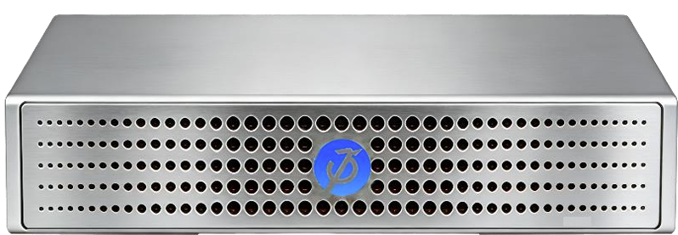

Housed in a compact 0.58L unibody aluminum-magnesium alloy chassis (150mm × 150mm × 26mm), GP Spark integrates a complete RDMA and NVMe-oF protocol stack into a dedicated ASIC chip via a hardware offload engine. With support for 100GbE networking and GPU Direct RDMA, data flows directly into GPU memory — delivering end-to-end latency under 20µs, throughput of up to 24GB/s, and up to 2.7 million IOPS, all within a total power envelope of under 100W. The passively-cooled unibody chassis ensures silent operation even under sustained 100% load.

Key Features
Seamless Integration, Plug & Play: Kernel-level seamless compatibility with the NVIDIA DGX Spark — no drivers required. Native support for NVMe-oF, RDMA, and GPU Direct Storage (GDS) ensures fast device recognition and rock-solid reliability.
Extreme Speed Expansion, Limitless Capacity: Supports up to four M.2 NVMe SSDs (2280 and 22110 form factors), with up to 16TB per drive (upgradeable) and flexible drive combinations to meet diverse storage needs. Multi-device clustering scales total capacity up to 256TB+.
Desktop Performance Champion: Transfer bandwidth of up to 12GB/s, access latency under 20µs, and total power consumption under 100W — delivering an outstanding energy efficiency ratio.
Portable Design, Effortless Deployment: A desktop-sized footprint that saves space, with plug-and-play setup for rapid deployment without complex configuration.

Application Scenarios
- AI large model training & inference (200B-parameter model loading, 70B model fine-tuning)
- RAG knowledge base construction (TB-scale real-time data retrieval)
- KV Cache externalization acceleration (200Gbps RDMA offload)
- High-speed data backup & migration
- 8K video editing & rendering
- Data science (DuckDB / Polars / Dask big data processing)
- Medical imaging analysis (sub-second 4D CT loading)
- Synthetic data closed-loop generation
- Edge AI deployment (low-altitude economy, smart cities, vehicle-infrastructure coordination)

Technical Specifications
Storage Protocol | NVMe-oF (NVMe over Fabrics)
Network Protocol | 100GbE RDMA (RoCE v2)
Max Capacity | 64TB per unit (16TB × 4), scalable to 256TB+ via multi-device clustering
Hardware Architecture | Dedicated ASIC Hardware Offload Engine
GPU Direct | Supports GPU Direct Storage (GDS) + GPU Direct RDMA
Performance | Up to 24GB/s throughput, up to 2.7 million IOPS, end-to-end latency under 20µs
Dimensions & Volume | 150mm × 150mm × 26mm (0.58L)
Power Consumption | < 100W
Chassis & Cooling | Unibody aluminum-magnesium alloy chassis, passive cooling, silent operation
Default IP & Port | 10.10.10.10/24 (Service Port: 4420)

CHAPTER 2: HARDWARE INSTALLATION

Package Contents
Please carefully verify that the following items are included after unboxing:
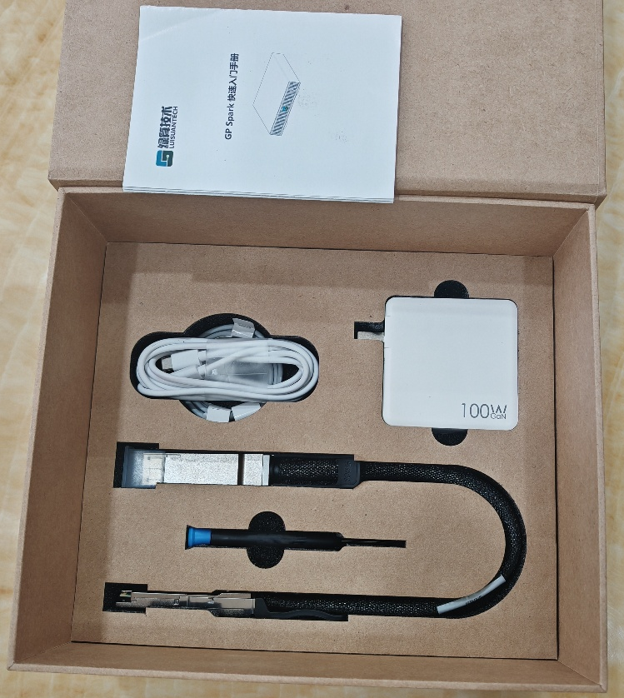
- GP Spark Main Unit × 1
- External DC Power Adapter × 1
- Power Cable × 1
- QSFP28 DAC High-Speed Cable (100GbE) × 1
- Quick Start Guide × 1
- Warranty Card × 1
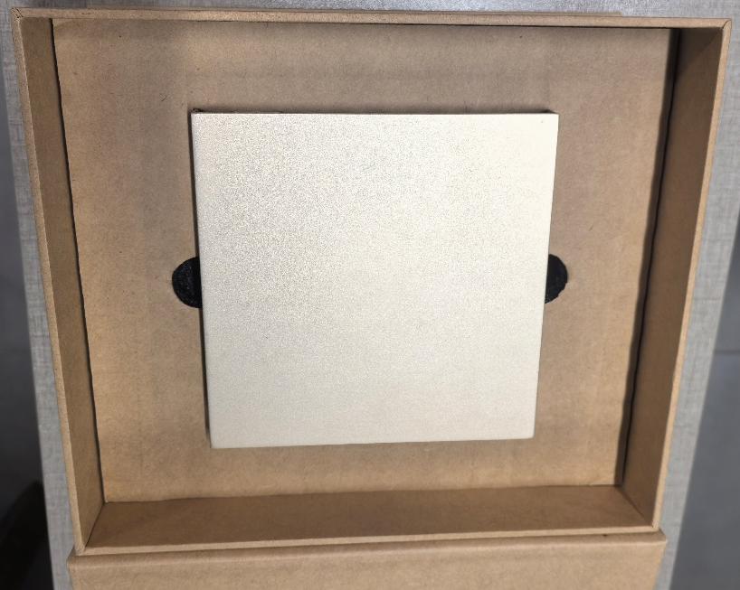

Step 1: Installing SSDs
- Ensure GP Spark is powered off and the power cable is unplugged.
- Use a Phillips screwdriver to remove the bottom cover.
- Insert each M.2 NVMe SSD (2280 or 22110 form factor) into an M.2 slot, gently press down, and secure it with a screw. Repeat for each additional drive.
- Replace the bottom cover and tighten the screws.
⚠ ESD Warning: Before installing or removing SSDs, touch a grounded metal object to discharge static electricity and prevent ESD damage to electronic components.

Step 2: Network Connection
- Connect one end of the 100G QSFP28 cable to the GP Spark's 100G QSFP28 port.
- Connect the other end to the host's (DGX Spark, workstation, or server) 100GbE network port.
- Ensure the cable is firmly seated, with no looseness.

Step 3: Power On
- Plug the DC power adapter into the GP Spark power port.
- Connect to power and wait approximately 30 seconds for the device to boot.
- Observe the front-panel indicators to confirm the device is operating normally.

LED Indicator Guide
Indicator | Status | Meaning
Power LED | Solid Green | Device powered normally
Power LED | Red | Device booting or fault
Network LED | Blinking Green | Network link up, data transmitting
Network LED | Solid Green | Network link up, no data
Network LED | Off | Network link down
Disk LED | Solid Blue | SSD recognized and normal
Disk LED | Blinking Blue | SSD reading/writing
Disk LED | Off | SSD not recognized or disk fault

CHAPTER 3: SOFTWARE CONFIGURATION

System Requirements
GP Spark supports the following operating systems (kernel version ≥ 4.13.0):
- CentOS 7.5 or later
- Ubuntu 18.04 or later
- Rocky Linux 9 or later
- Kylin V10 SP1 or later
- UnionTech UOS
- CS2C Foundry / Loongson OS
⚠ NIC Requirement: The host must be equipped with one of the following NICs: NVIDIA Mellanox ConnectX-4 / ConnectX-5 / ConnectX-6 / ConnectX-7 Series, or Luisuan Technology LS00201V11 Series.

Network Configuration
The factory default IP address of GP Spark is 10.10.10.10/24. Configure the host network port to an address within the same subnet (e.g., 10.10.10.1/24), then verify connectivity:
ping 10.10.10.10

Installing NVMe Tools
After configuring the IP address, install the nvme-cli management tool (the host requires internet access for this step):
CentOS: sudo yum install -y nvme-cli
Ubuntu: sudo apt-get install -y nvme-cli

Loading RDMA Drivers
Use the following commands to load the RDMA-related kernel modules:
sudo modprobe nvme_fabrics
sudo modprobe rdma_cm
sudo modprobe nvme
sudo modprobe -v nvme_core multipath=0
sudo modprobe -v nvme_rdma register_always=0

Jumbo Frame Configuration
For optimal performance, set the MTU to 4096 (Jumbo Frame) on both the host and GP Spark network interfaces:
sudo ip link set dev <interface_name> mtu 4096

CHAPTER 4: STORAGE MANAGEMENT — DISK DISCOVERY & MOUNTING

Discovering NVMe Disks
Use the following command to discover the NVMe SSDs available on GP Spark:
sudo nvme discover --transport=rdma --traddr=10.10.10.10 --trsvcid=4420
A successful execution returns a Discovery Log entry containing fields such as trtype, adrfam, subtype, treq, portid, trsvcid, subnqn, traddr, rdma_prtype, rdma_qptype, rdma_cms, and rdma_pkey. Note the subnqn value, as it is required for the connection step below.

Connection & Mounting
Use the following command to connect to and mount the NVMe disk, where <subnqn> is the value obtained from the discovery step above:
sudo nvme connect --transport=rdma --traddr=10.10.10.10 --trsvcid=4420 --nqn=<subnqn> --nr-io-queues=8
A successful connection produces no output. Verify the connection using either of the following commands:
nvme list
lsblk

Formatting & File System
On first use, the SSD must be partitioned and formatted. If the SSD has already been formatted on another system, this step may be skipped and the disk mounted directly.
sudo fdisk /dev/nvme0n1
sudo mkfs.ext4 /dev/nvme0n1p1
sudo mkdir -p /mnt/gpspark
sudo mount /dev/nvme0n1p1 /mnt/gpspark
df -h
⚠ IMPORTANT WARNING: Do NOT add GP Spark disk mount entries to /etc/fstab.
Because GP Spark connects via the Ethernet NVMe-oF protocol rather than a local PCIe bus, the device cannot be recognized when fstab executes mount operations during system boot. Adding GP Spark entries to fstab will result in disk loading failure or boot failure. After every reboot, manually mount the disk using the nvme connect command shown above. For automatic mounting at boot, use a systemd service or rc.local instead of fstab.
If a misconfiguration has already caused the system to fail to boot normally, follow these recovery steps:
- Enter Single User Mode.
- Edit /etc/fstab and remove the GP Spark disk entries.
- Reboot the system.
- After the system boots normally, manually mount the disk using nvme-cli commands.

CHAPTER 5: APPLICATION EXAMPLES

1. NVIDIA DGX Spark High-Speed Storage Expansion
The built-in 4TB NVMe SSD in the NVIDIA DGX Spark often becomes a bottleneck when processing large datasets. With GP Spark, you can:
- Preload datasets into GP Spark's 16TB cache pool with an average latency of only 68µs.
- Achieve direct GPU passthrough to NVIDIA Blackwell Tensor Cores via a single 100GbE link (12.5GB/s) combined with GPU Direct RDMA.
- Enjoy a true “what-you-think-is-what-you-get” desktop AI development experience.

2. LLM Fine-Tuning & Training
Solution 1 – Full Activation and Gradient Offload to GP Spark: Leverage NVIDIA GPU Direct Storage and RDMA for Storage to fully offload the activation values and gradient states of a 70B model to GP Spark, sustaining high GPU utilization throughout the training run.
Solution 2 – Zero-Copy Checkpoint Fast Switching: GP Spark supports RDMA zero-copy snapshots, enabling rapid saving of complete 70B checkpoints. If an experiment fails, perform a one-click rollback to the previous checkpoint and resume training instantly — as smooth as loading a saved game — dramatically reducing training downtime.
Solution 3 – 200B Model Cold-Start Acceleration: GP Spark supports NVIDIA Model Streamer combined with RDMA weight streaming. Model weights are sharded and pre-sharded across four SSDs; at inference launch, four concurrent 100G RDMA channels transfer data in parallel. NVIDIA Blackwell 5th-Gen Tensor Cores begin computation while weights are still being received, achieving true zero-wait pipelining between weight loading and inference.

3. Edge AI Deployment
Paired with the NVIDIA DGX Spark, GP Spark can be used to build “City-Scale Edge AI Deployment Units” — compact, low-power systems built on compute-storage convergence and suitable for large-scale distributed deployment. Typical applications include:
- Low-altitude flight compliance audits (drone fleet scheduling, airspace management)
- Vehicle-infrastructure cooperative safety verification
- Robotic inspection
- Campus video AI analytics
- Edge data governance

CHAPTER 6: TROUBLESHOOTING & SAFETY

Device Won't Power On
- Check that the power adapter is properly connected.
- Check that the power cable is undamaged.
- Observe the front-panel indicator status.
- Try replacing the power cable or power adapter.

Network Unreachable (Ping Fails)
- Check that the cable is properly connected, with no looseness.
- Use ip link show to confirm the port status is UP.
- Confirm the host IP address is within the 10.10.10.0/24 subnet.
- Try disabling auto-negotiation: ethtool -s <eth> speed 100000 duplex full autoneg off

NVMe Discovery Failed
- Confirm the RDMA drivers are loaded (lsmod | grep nvme).
- Confirm nvme-cli is installed.
- Confirm port 4420 is not blocked by the firewall.
- Try restarting the GP Spark device.

Performance Below Expectations After Mount
- Check that Jumbo Frames are configured (MTU 4096).
- Confirm a 100GbE cable is in use (not a standard Gigabit Ethernet cable).
- Check that the --nr-io-queues parameter is set to 8.
- Confirm the SSD's own performance meets its rated specifications.

System Hangs / Fails to Boot
- The GP Spark disk may have been added to /etc/fstab.
- Enter Single User Mode and remove the corresponding entries.
- After rebooting, manually mount the disk using nvme connect.

Device Overheating
- Ensure the ventilation openings are not obstructed.
- Check whether the ambient temperature exceeds 40°C (104°F).
- Confirm the fan is operating normally.
- If the fan is faulty, contact After-Sales Support.

Important Notes
[!] Do Not Write GP Spark Disks to fstab
GP Spark connects via the Ethernet NVMe-oF protocol, not local PCIe. fstab cannot recognize the device at system boot, which will cause boot failure. Always mount the disk manually after each boot (see Chapter 4).
[!] Proper Shutdown Procedure
Before powering off, first unmount the file system (sudo umount /mnt/gpspark), then disconnect the NVMe-oF session (sudo nvme disconnect -n <nqn>), and finally power off GP Spark.
[!] Power Requirements
Use only the original factory-supplied power adapter. Do not use non-original or damaged power adapters.
[!] Cooling & Ventilation
The device has ventilation openings on the bottom and sides — do not obstruct them. Do not place the device in an enclosed space or on a fabric surface.
[!] Network Environment
The default IP address of GP Spark is 10.10.10.10/24. Ensure the host NIC IP address is in the same subnet. A direct connection (without a switch) is recommended for the lowest latency.
[!] SSD Compatibility
GP Spark supports M.2 2280 and 22110 form factor NVMe SSDs. Enterprise-grade high-performance SSDs are recommended; QLC low-end SSDs are not recommended.
[!] ESD Protection
When installing or removing SSDs, touch a metal object first to discharge static electricity and avoid ESD damage to electronic components.

CHAPTER 7: WARRANTY & SUPPORT

Warranty Policy
- The GP Spark main unit carries a 1 or 3(option)-years limited warranty from the date of purchase.
- Accessories (power adapter, cables) carry a 1-year limited warranty.
- SSDs are covered under their original manufacturer's warranty policy.
- Human-caused damage, natural disasters, and unauthorized modifications are not covered under warranty.

Technical Support
- Technical Support Email: jacky.kuan@eagleheart.com.tw
- Official Website: https://eagle-heart.com/
- Technical Documentation: Visit the official website for the latest user manuals, white papers, and FAQs.
- Community Support: Follow our GitHub repository for open-source tools and examples.

Contact Us
- Company Name: Eagleheart Technology Co., Ltd.
- Subsidiary: Hangzhou Luisuan Technology Co., Ltd.
- Website: https://eagle-heart.com/
- Technical Support: jacky.kuan@eagleheart.com.tw
— This document is prepared by the Eagleheart Technology Partner Team; data current as of June 2026 —
Eagleheart Technology Co., Ltd. · Luisuan Tech ·https://eagle-heart.com/

